Dimensions of Mind
Anna Garren

Background
In 2007, psychologists Heather Gray, Kurt Gray, and Daniel Wegner published a research paper exploring the dimensions of mind perception. They conducted an online survey asking participants which of two presented characters would be more likely to present a given mind capacity. The results showed that there were two dimensions of mind perception: experience and agency. Ten years later, in response to this publication, two teams of psychologists further investigated these claims. Kara Weisman, Carol Dweck, and Ellen Markman (hereafter referred to as Dweck) from Stanford Universtiy conducted 4 studies, while Bertram Malle from Brown University did the same. For comparison between the two teams, we are using Dweck’s study 4 and Malle’s study 2. This is because Dweck’s other studies only compare two characters, a beetle and a robot, and Malle’s other studies asked a slightly different question of the participants. Dweck found there were 3 dimensions of mind: body, heart, and mind, while Malle found Affect, Moral/Mental, and Reality Interaction.

The Studies
Dweck’s study observed participant’s perceptions of the presence of 40 mental capacities in 21 characters. Each participant was presented one character to evaluate and was asked about 40 mental capacities. Malle’s study did similarly, but with 3 characters and 54 mental capacities. The characters both studies had in common were adult, child, and robot. They had 16 items in common which composed of roughly equal parts of each of the three factors from the two studies.

Figure 1: items of both studies
Dweck | Similar (Dweck / Malle) | Malle
Body:  fear  calm  safe  nauseated  conscious  personality  thoughts  free will  odors  Heart:  guilt  embarrassed  right v wrong  disrespected  pride  depressed  Self-aware  computations  Mind:  remembering  depth  seeing  recognizing others  working toward goals | Body / Affect:  Hungry / hungry  Pain / pain  Pleasure / pleasure  Angry / angry  Desires / desires  Mind / Affect:  joy / happy  Love / loving  Body / Moral/Mental:  Intentions / set goals  Heart / Moral/Mental:  holding belles / uphold morals  Reasoning / reason  understanding feeling / understand minds  Self-restraint/Self-control  Mind / Moral/Mental:  making choices / deliberate before action  Communicating / verbal communication  Mind / Reality Interaction:  detecting sounds / seeing hearing  sensing temp / temp and touch | Affect:  panic  emotions  intense urges  smelling/tasting  stress  disliking pol  gratitude  compassion  imagining  sexual  Moral/Mental:  reasons for  planning  understand goals  explaining decisions  praise moral  disapprove moral  taking person visual poy  inferring thoughts  norms  Reality Interaction:  moving on own  nonverbal comm  learn by imitation

The Questions
Why did Dweck and Malle find different dimensions of mind? What are the true dimensions of mind perception?

Why did Dweck and Malle find different dimensions of mind?

Were the dimensions different?

Methods

Results

Was it because of different characters?

Methods
If Dweck had only used the same characters as Malle did, would he have gotten different results? Using Dweck’s raw data, two PCA’s were run. Both had all of the original 40 items, but one data set used only the 3 characters in common with Malle (adult, child, robot), while the other data set used all of the original 21 characters found in Dweck’s report. The two factor loadings resulting from the PCA were compared quantitatively and qualitatively.

Results
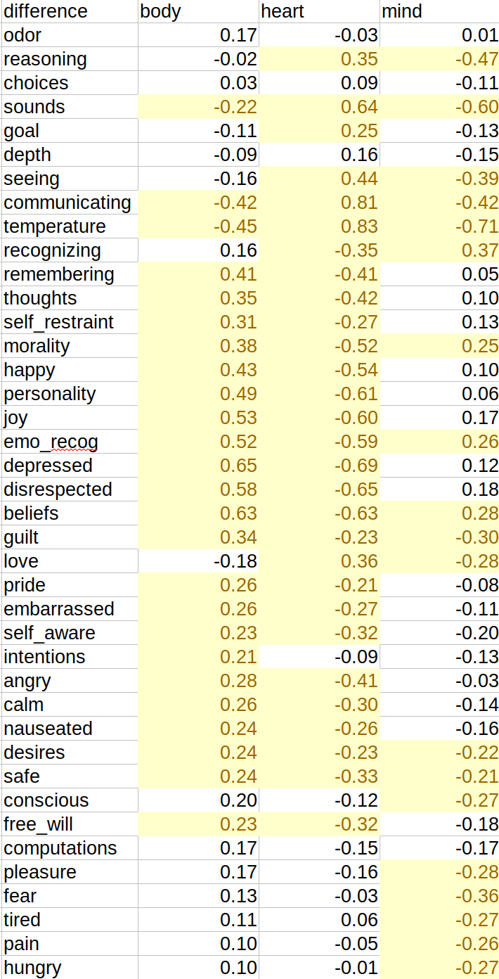
Using data that contained data for 3 characters produced different factor loadings than using data for 21 characters, but the difference was not consequential towards our hypothesis. The difference between the factor loadings in using 3 characters and 21 characters are shown in Figure 2. From the two PCA’s, we compared 16 of the items, the ones in common with Malle, to Malle’s factors for those items. This analysis is found in Figure 3. Items highlighted in red are highly loaded on the same factor as in Malle’s report. It was found that some of the loadings for these items changed. 43% of the items loaded on the same factors for Dweck as Malle when using 3 characters, while 68% of the items loaded on the same factors when using 21 characters. This is a 25% increase in similarity going from 21 characters to using just adult, child, and robot. It seems that use of different characters contributed to different results for Dweck and Malle.

Figure 2: Difference between loadings for 3 characters and 40 items and 21 characters and 40 items. Loadings that differ more than 0.2 are highlighted.

Figure 3: factors for 3 and 21 character PCA’s
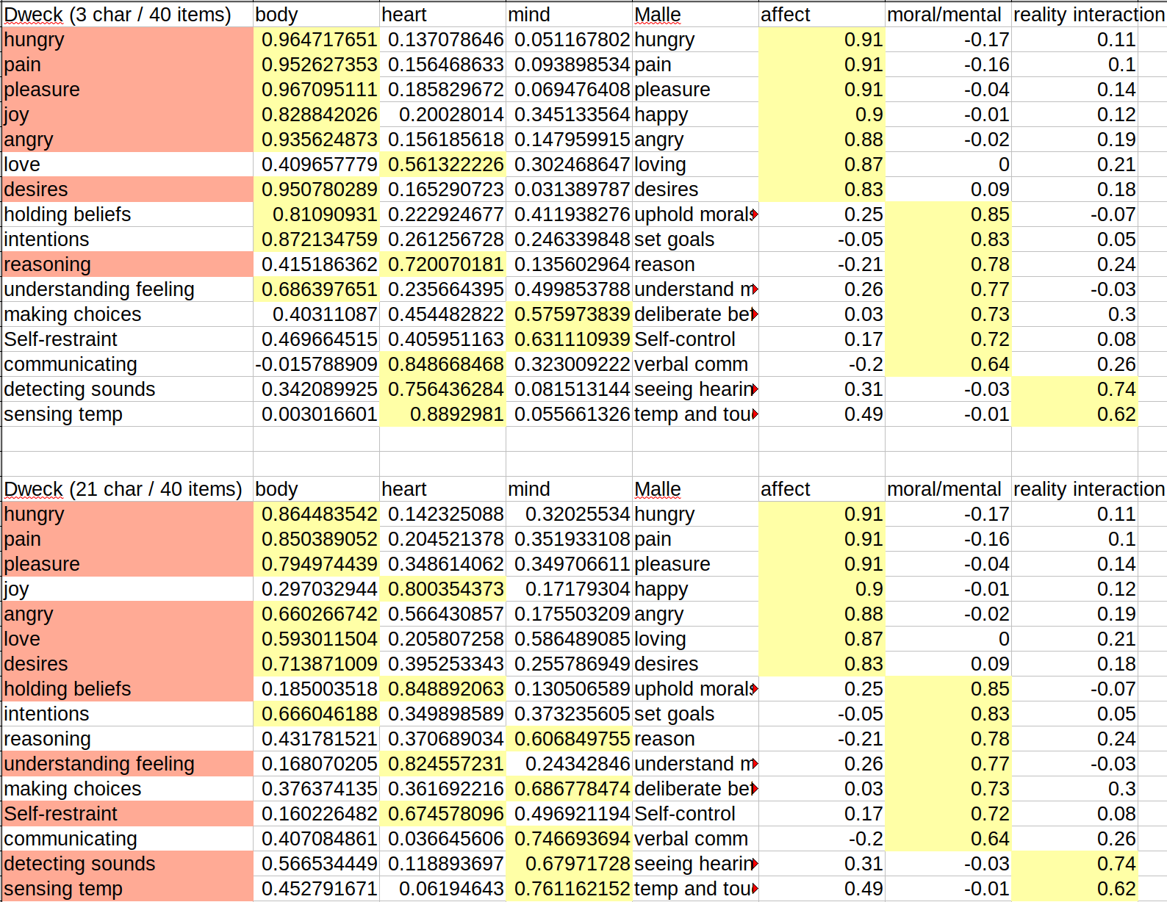

Was it because of different mental capacities?

Methods
If Dweck used only the same items as Malle, would he have gotten the same results as Malle originally did? Likewise, if Malle had used only the same items as Dweck, would he have gotten the same results as Dweck originally did?Two PCA’s were run on two data sets. One data set had Dweck’s original 21 characters, but only the 16 items Dweck had in common with Malle. The other data set was Dweck’s original dataset with 21 characters and 40 items (mental capacities). The difference in factors between the 40 item and 16 item data sets were qualitatively analyzed.

Results
The loadings for the two PCA’s run with Dweck’s data are in Figure 1. When comparing the factors these items load on with the factors these same items load on in Malle’s report, we see that Dweck’s factors are most similar to Malle’s original factors when using only the 16 items Dweck has in common with Malle in the analyses (Figure 2). Items highlighted in red are highly loaded on the same factor as in Malle’s report. It seems that the use of different mental capacities contributed to the difference in results for Malle and Dweck.
Figure 1: Loadings for 21 characters and 16 items and 21 characters and 40 items
Dweck PCA with 21 Characters and 16 Items | Dweck PCA with 21 Characters and 40 Items
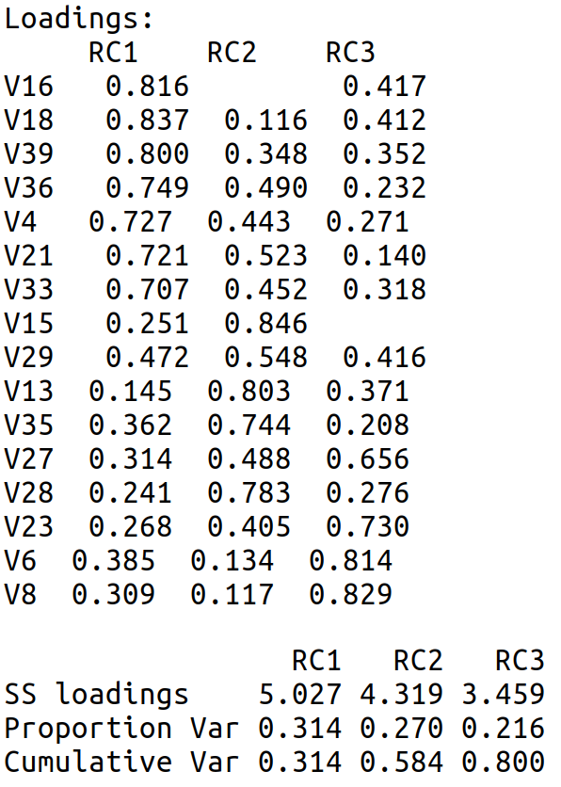 | 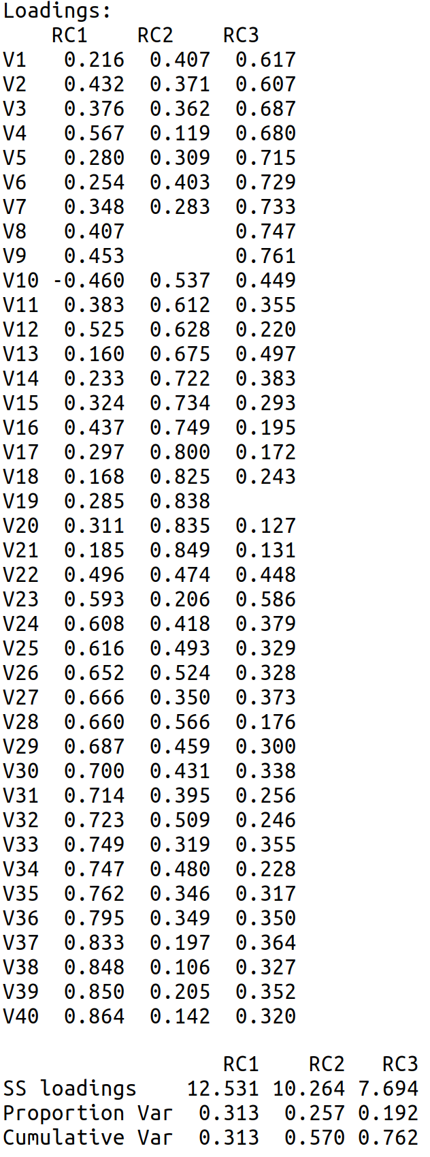

Figure 2: factors for 16 and 40 item PCA’s
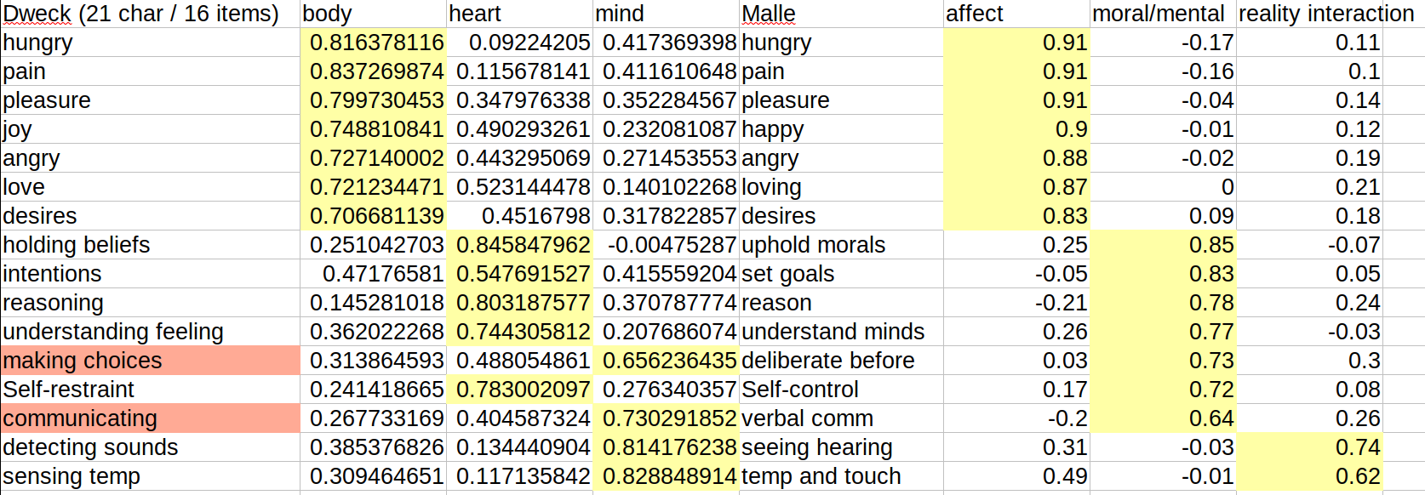
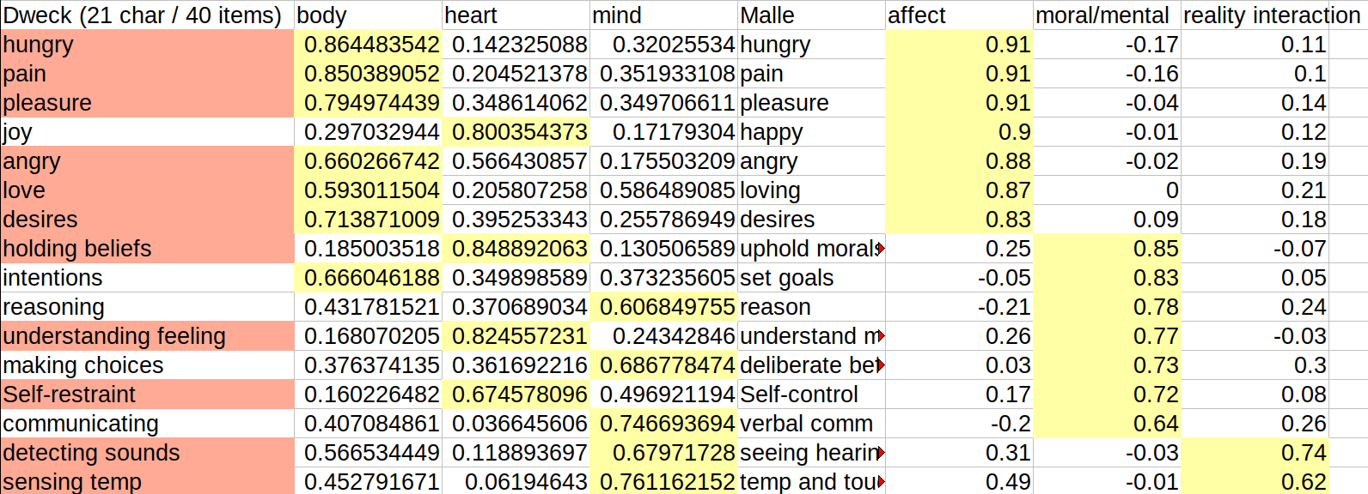

Was it because of different data?

Methods

Results

What are the true dimensions of mind perception?

Methods

Results

